**Mobile Modification**



**Agile Project**

**Bachelor of Computer Application**



**Presented by:- Atul Singh (500066715)**

**Anshika Srivastava (500071410)**

**Arnav Singh (500069041)**

**Under the guidance of:-Durgansh Sharma**

**Department of Computer Science**

**University of Petroleum and Energy Studies**

**Dehradun-248007**

Table of Contents

Introduction 3

Objectives 4

I. Functionality 6

II. Efficiency 6

III. Reliability 6

IV. Usability 6

V. Maintainability 6

VI. Portability 6

Manifesto 20

ER-DIAGRAM 24

UML(Unified Modified Language) 25

DFD LEVEL 0 26

DFD LEVEL 1 27

PERT CHART 28

Pert chart network diagram 28

Algorithm 31

State Chart Diagram 32

Sequence Diagram 33

Abstract Views 34

Class Diagram 36

Use of Agile Methodology in Project 37

**Introduction**

**Welcome we are in 21th century and we are encompassed with various sorts of devices and advances and cell phone is one of gadget which assume a significant job in it. To keep this in my psyche my point is about it . "MOB- MOD" here "MOB" alludes versatile and "MOD" alludes adjustment implies portable alteration.**

**As of late India has enlisted its name at number two in the wake of overcoming USA in the offer of cell phone. Since today every individual has a cell phone in his grasp. Individuals are partial to cell phones and its highlights. Some like its camera, a few its processor, a few its presentation and a few its sound quality Which they don't get in one, in spite of putting such a lot of cash on it. Some cell phones have great sound, a few cameras, a few processors, some showcase and some for constructed quality. Try not to allow to individuals to decide for themselves what they need. I and my gathering have taken a shot at it and made it conceivable through that thought.**

**This is a crisply new project dependent on spry framework that will assume a significant job in the field of innovation In this thought. we are propelling this from the online stage through our own E business internet shopping webpage, with the goal that it tends to be effectively accessible to everybody and individuals can exploit it effectively in anyplace, wherever, whenever.**

# Objectives

* Modification**- A modification is a change or alteration, usually to make something work better. If you want to change something — in other words, modify it — you need to make a modification. Lots of things require modification, because they get older or just because they can be improved.If something is to be added or removed as demanded by the customer. Such as display ,audio, built-in- quality, different color, camera etc as per their wish. Something they have not had before.**
* Anything that we want,nothing we don’t & Priority choices - If someone has not enough budget.It does not matter whoever wants. They will get the product accordingly. The real focus will be on that thing which they really want as priority. Which will give them a different experience and no money will be spent in those,this will serve as customer self-satisfaction.
* Time saving- Often people waste their time waiting for something .About which they do not remain sure that thing will be the same or will be slightly different. Often, but the results are not found. But through this, people will save time and they will find them what they want. Which makes it better than everything else.

## Sub-objective

* **Awareness and knowledge- People are often cheated if they do not know much about them. Through this, people will get more information and awareness will also be there. Which item is for how much. What can it do. How much will it last. And will keep our society connected with technology**

**Software characteristics**

The software characteristics are significant on that premise it is actualized in our venture that are fundamental. Contemplating the undertaking viewpoint the attributes are the characteristics while building up the product or the task so as to meet the end client prerequisites.

Functionality

Portability

Efficiency

System characteristics

Usability

Maintainability

Reliability

Characteristics are as follows

1. Functionality
2. Efficiency
3. Reliability
4. Usability
5. Maintainability
6. Portability

Functionality

This is a part of programming trademark that alludes to the presentation of a product that produce in a time allotment. Means it alludes to the level of execution for a planned reason. It plays out the specific sort of capacities as observed underneath:

In our undertaking the first under programming qualities is the Functionality. This is key element and done in like manner. As indicated by our undertaking we need greatest yield in an assigned time span. Our undertaking will stick to the conventions and will be practical over the long haul

Functions are as follows:-

Suitability: The end client may like the item it should reasonable for the client implies that client can utilize capacities to play out a predefined undertaking and client goals.

Accuracy: The product or the item ought to be exact so as to yield better outcomes that implies that it ought to give the correct air to the working item and impacts ought to be acceptable.

Interoperability: The product or the item ought to be fit for interfacing with at least one frameworks.

Compliance: The product or the item ought to hold fast to the conventions this is called consistence.

Security: the product or the item ought to be made sure about with the goal that no unapproved client can get entrance into the frameworks. This the key element our item ought to be made sure about by the unapproved get to.

Reliability

This is additionally a product trademark where the item that the end client is utilizing ought to keep up it execution capacity and ready to remain under a specific time span. That is the point at which we state that the product is solid to utilize. It plays out certain capacities they are as per the following:

In our undertaking the second under programming trademark is Reliability. Our item will attempt to keep up the degree of execution and ready to remain under the specific condition and ready to convey the yield in an assigned time period, the capacities are as per the following:

Recoverability: Our item will have the option to recoup from a circumstance like if our item has fizzled or smashed it will have the option to recuperate and keep up its presentation in a situation. This is significant component as our item will ready to attempt to consolidate this.

Adaptation to internal failure: Our item will ready to deal with the adaptation to internal failure on the off chance that the disappointment is seen in our framework or an item it will attempt to keep up the degree of execution and ready to recover information on the off chance that incidents happens.

Development: Our item will be attempt to evade disappointment and here the development assumes an indispensable job in our undertaking.

Usability

This is a product trademark where the product or the item can be utilized by the end client easily the measure of exertion or time will be diminished this will bring about quicker comprehension of the item. Ease of use plays out specific capacities as follows:

In our task the third under programming trademark is Usability, this is a significant element of the product trademark so client can comprehend the item in a quicker way. There are some sure capacities that are there as follows :

Understandability: Our item will be straightforward that how the item will be utilized it will likewise be appropriate for the client to utilize this will bring about where the client can peruse certain realities with only a press of a catch. Right now the client needs to peruse a book it can legitimately accumulate information without a substantial book close by or by a computerized reasoning voice can peruse the book just by the maintenance of the information.

Learnability: Our item will be a lot simpler to learn and how the item will really function face to face it will exhibit the viable perspective in a given situation. This would empower the clients to learn it quicker.

Operability: Our item will be anything but difficult to work and is easy to understand simultaneously with this item they can use in their day by day schedule or busy working or on a get-away too.

Efficiency

This is a product trademark where the product or an item will attempt to use least memory space and will have the option to execute the undertakings a lot quicker. Our venture will have the option to do that. There specific capacities that is expected to remember to plan such an item :

In our venture the fourth under programming trademark is the Efficiency, as referenced prior our item will be productive to deal with and to use by the end client.

In Resource: Our item will have the option to utilize required assets in a suitable time span when our item needs to play out a predefined activity under an apportioned time allotment.

In Time: Our item will ready to convey reaction time and the throughput will be quicker under a base time period.

Maintainability

This is a product trademark by which we can adjust or update the product and improve its presentation and right the mistakes. The product ready to keep up and will get new highlights too. It plays out certain capacities:

In our venture the fifth one under programming trademark is Maintainability, our task will give a move up to the item any place fundamental and will convey what the end client needs and will be at the ideal level. The capacities are as per the following:

Testability: Our item will be completely tried and endorsed yet in the event of a disappointment it will attempt to keep up its presentation and reinforcement will likewise be there if the information is lost.

Dependability: Our item will be a steady item so a that it doesn't send any undesirable overhauls and it will be made sure about also.

Variability: Our item will be effectively alterable and it will empower a predetermined alteration to be executed to the planned part.

Operability: Our item will have high estimation of operable and by that client can play out the errands a lot quicker and in a constrained time span. The item will have elevated level of framework programming running and application too.

Portability

This is a product trademark where the product is moved starting with one condition then onto the next with least changes. The capacities are as per the following:

In our venture the last one in the product trademark is the Portability, our item will be acceptable to utilize and will be compact also and play out the assignments a lot quicker in any event, when moved starting with one condition then onto the next. The capacities are talked about:

Flexibility: Our item will have the option to versatile for the various conditions also and ready to meet the prerequisites determined.

Introduce capacity: Our item will be installable in any predetermined condition also.

Replaceability: Our item can supplant different items that depends from item and the method for working.

Principles behind the Agile Manifesto

* **“Our highest priority is to satisfy the customer  
  through early and continuous delivery  
  of valuable software.”**

**In order to satisfy our customer with our services and products, we would regularly keep our online store updated and refreshed. The customer can any day find the latest technology on our store updated. We would ensure a regular listing of the latest and the most powerful hardwares on our website. The customer can then customize their phone among the latest technology then and there itself without waiting any further.**

* **Welcome changing requirements, even late in  
  development. Agile processes harness change for  
  the customer's competitive advantage.**

**Our developers end would always be happy to implement any last moment changes on the wish of our customers. We aim to satisfy our customers only after introducing them to current trends and not to the older versions. If the customer finds that something new has come up in the market then it would be our prime job to list it on our store and also suggest it to our customers. We will also be ready to implement any changes if the customer wants any new feature to be added to our product or services.**

* **“Deliver working software frequently, from a  
  couple of weeks to a couple of months, with a  
  preference to the shorter timescale.”**

**In order in ensure that we our developing a right project not only according to us but also according to our end user, we will give our working model more often than just giving them to use it at the end. In this manner we would build a satisfaction in the customer that will also serve as positive feedback for us. If a customer file any negative review against our product then we will bring in necessary reforms to the implement the changes according to the customers taste demand. In this way our customer will also know in advance in advance that something new is being built by us which is going to solve their problem.**

* **“Business people and developers must work  
  together daily throughout the project.”**

**It would be our continuous efforts to acknowledge the business end about what we are doing and the things we have achieved so far through presentations and sample outputs. The developers must be also ensured that what they are building is totally in interest of the business people. If the business end wants to bring any changes in the project then we may certainly do so. We will always ensure that our sponsors and our stakeholders are relaxed and are regularly updated about the activities that is going on in our organization with their invested money.**

* **“Build projects around motivated individuals.  
  Give them the environment and support they need,  
  and trust them to get the job done.”**

**We believe that our team should always be motivated and furnished with any kind of resources they want in order to bring out the best from themselves. We will build a group of passionate employees who are drive-driven personalities. In all manner we will avoid the destructive people in our as they bring in the negative impact on any kind of work. We will ensure that our team gets what they demands so that we may seek the maximum inputs from them. If our team has any better alternative to any problem then we will surely entertain their idea and implement them if the idea is deserving.**

* **“The most efficient and effective method of  
  conveying information to and within a development  
  team is face-to-face conversation.”**

**In an organization there could be lots of barriers to communication. It may exist in the form of physical barriers, psychological barrier, language barrier and also in other forms. The best way to avoid the barriers is to implement face to face conversation. The avoidance of medium in communication channel surely brings down the barriers to a very great extent.**

* **“Working software is the primary measure of progress.”**

**Software is called completed only when it has been delivered to the end user. Till the process the software is in creation, the primary measure of progress is the functionality of the features which have been added so far in the project. The feature should properly which has been covered so far. This is the time where the team should focus more on the efficiency of the product rather than worrying about the deadline.**

* **“Agile processes promote sustainable development.  
  The sponsors, developers, and users should be able  
  to maintain a constant pace indefinitely.”**

**The process should move in a constant pace in the whole process. When a team has very less target then the team should hurry to complete the task. On the other side when the team has a huge target then they should not build a very busy schedule for themselves. If the pace is not maintained then sometimes the developers might spend lots of time I doing nothing and sometimes they might get exhausted without achieving the required target. This is applicable not only for developers but also for sponsors, advertisers and designers.**

* **“Continuous attention to technical excellence  
  and good design enhances agility.”**

**The technically astounding software along with a good design makes the whole agile process a very better experience. The capable programmers might end up giving a very complex solution which might be not needed and very difficult for end user to understand. Therefore our constant efforts would be to create a very efficient software with less complexity and with a better design. So that the end user can use it with a great involvement without being a “tech geek”.**

* **“Simplicity--the art of maximizing the amount  
  of work not done--is essential.”**

**The software should not contain any feature which the user might not even once use it in their lifetime. In this manner the whole effort which was put into developing that feature goes waste.Therefore we will make a list of “must have” and “nice to have” features in our software. Accordingly our developers would deploy more efforts on “must have list rather than focusing more on “nice to have” list.**

* **“The best architectures, requirements, and designs  
  emerge from self-organizing teams.”**

**Freedom is the prerequisite element for any team project to emerge as great player. The team should be given a space to think what according to them would meet best to the current situation. Even if the team consist of a specialist then also the final result is not assured. In order to avoid this crisis we will create a self-organizing team under controlled environment which would be permitted to think, invent and make mistakes.**

* **“At regular intervals, the team reflects on how  
  to become more effective, then tunes and adjusts  
  its behavior accordingly.”**

**One of our core values of the business is responding to the changes over following a plan. Our team will be advised to reflect upon their past activities and improve upon their methodologies and workflow adopted if there exists a problem making element. We will make a ten days sprint and at every tenth day we will retrospect our past activities and work upon our failure.**

# 

# Manifesto

**Individuals and interactions over processes and tools-**

**The first core value of the Agile Manifesto is to value individuals and interactions over processes and tools. When you allow each person to contribute unique value to your software development project, the result can be powerful.**

**If processes and tools are seen as the way to manage product development and everything associated with it, people and the way they approach the work must conform to the processes and tools. Conformity makes it hard to accommodate new ideas, new requirements, and new thinking. Agile approaches, however, value people over process. This emphasis on individuals and teams puts the focus on people and their energy, innovation, and ability to solve problems. You use processes and tools in agile project management, but they’re intentionally streamlined and directly support product creation. The more robust a process or tool, the more you spend on its care and feeding and the more you defer to it. With people front and center, however, the result is a leap in productivity. An agile environment is human-centric and participatory and can be readily adapted to new ideas and innovations.**

**If you value processes and tools, the benefits are that the processes are generally clear and well-understood, and you have a written record of communications about the project. However, if you value individuals and interactions highly, you realize greater benefits:**

* **Communication is clear and effective.**
* **Communication is quick and efficient.**
* **Teamwork becomes strong as people work together.**
* **Development teams can self-organize.**
* **Development teams have more chances to innovate.**
* **Development teams can customize processes as necessary.**
* **Development team members can take personal ownership of the project.**
* **Development team members can have deeper job satisfaction.**

**Of course, development team members must have the capacity to be involved, responsible, and innovative. Team members may need to let go of ego to work well within the team. But these disadvantages are minor compared with those that often attend processes that value process above people:**

* **People may over-rely on processes instead of finding the best ways to create good products.**
* **One process doesn’t fit all teams — different people have different work styles.**
* **One process doesn’t fit all projects.**
* **Communication can be ambiguous and time-consuming**

**Working software over comprehensive documentation-**

**A software development team’s focus should be on producing working products. The second Agile core value emphasizes working software over comprehensive documentation.**

**On projects using agile management tools, the only way to measure whether you are truly done with a product requirement is to produce the working product feature associated with that requirement. For software products, working software means the software meets what’s called the *definition of done:* at the very least, developed, tested, integrated, and documented. After all, the working product is the reason for the project**

**Customer collaboration over contract negotiation-Agile management principles extend to your relationship with the customer. Agile’s third core value emphasizes customer collaboration. The agile pioneers understood that collaboration, rather than confrontation, produces better, leaner, more useful products. As a result of this understanding, agile methodologies make the customer part of the project on an ongoing basis.**

**Historical project management approaches usually involve customers at three key points:**

* **Project start: When the customer and the project manager — or another project team representative — negotiate contract details.**
* **Any time scope changes during the project: When the customer and the project manager negotiate changes to the contract.**
* **End of a project: When the project team delivers a completed product to the customer. If the product doesn’t meet customer expectations, the project manager and the customer negotiate additional changes to the contract.**
* **Responding to change over following a plan-**
* **The fourth core value of Agile project management addresses the response to change. Change is a valuable tool for creating great products. Using agile management principles, project teams that can respond quickly to customers, product users, and the market in general are able to develop relevant, helpful products that people want to use.**
* **Unfortunately, traditional project management approaches attempt to wrestle the change monster to the ground and pin it down so it goes out for the count. Rigorous change management procedures and budget structures that can’t accommodate new product requirements make changes difficult. Traditional project teams often find themselves blindly following a plan, missing opportunities to create more valuable products. As time — and knowledge about your product — increases, the ability to make changes decreases, and costs more**

# ER-DIAGRAM

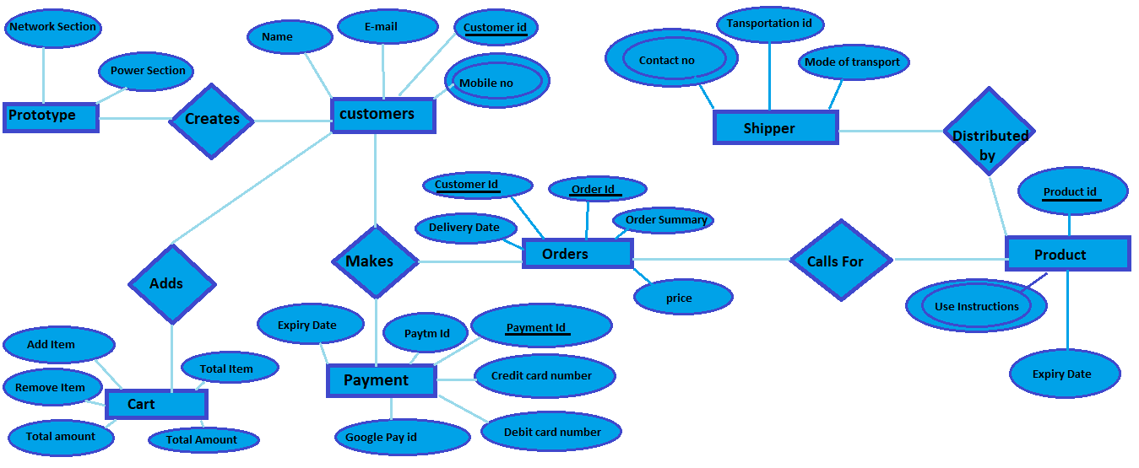

# UML(Unified Modified Language)

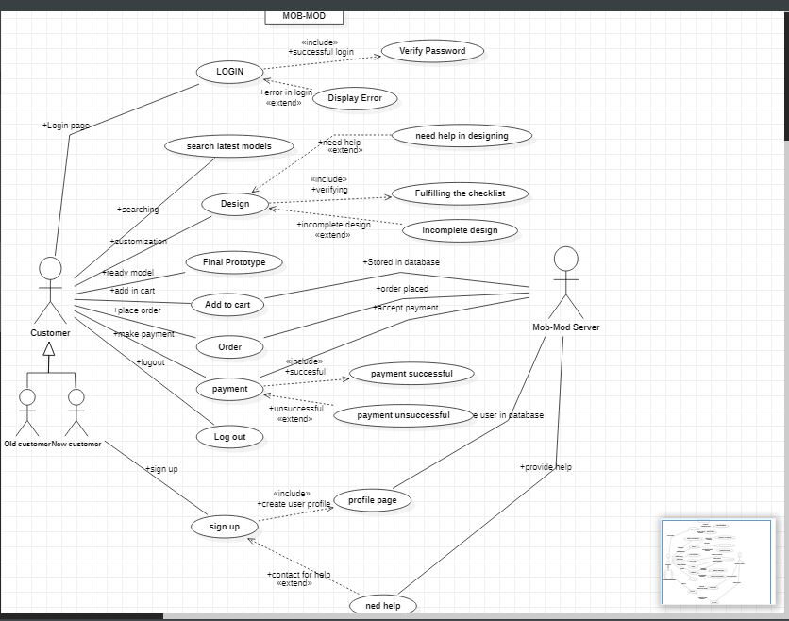

# DFD LEVEL 0

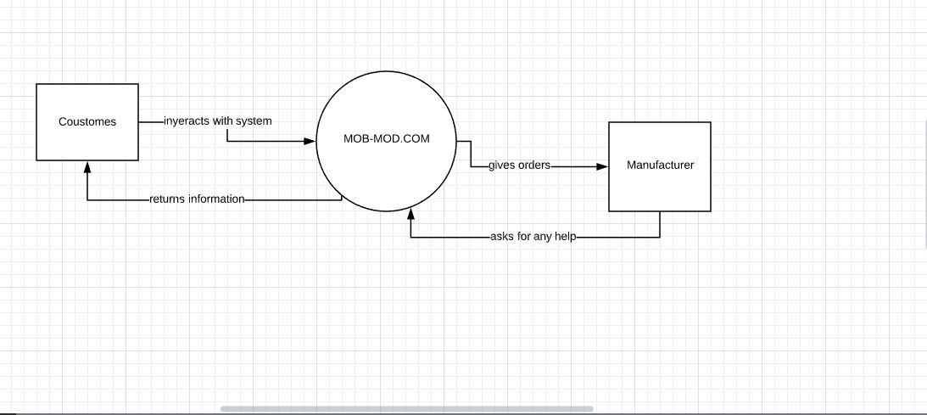

# DFD LEVEL 1

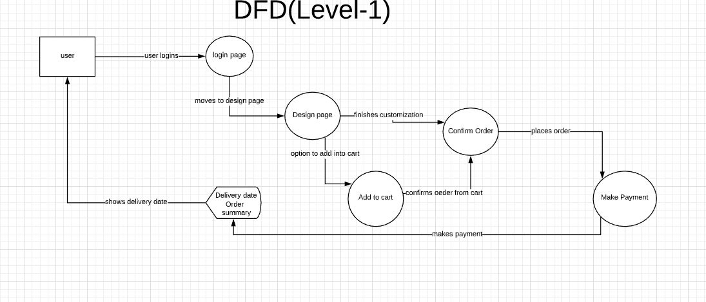

# PERT CHART

Pert chart is a project management tool used to plan, sort out, and arrange assignments inside a task. It is essentially a technique to analyze the charts associated with finishing a given venture, particularly the time expected to finish each undertaking, and to distinguish the base time expected to finish the all out task.

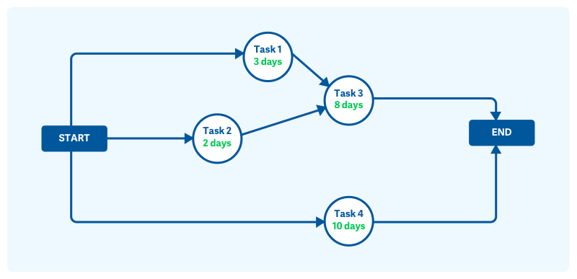

**Pert chart network diagram**

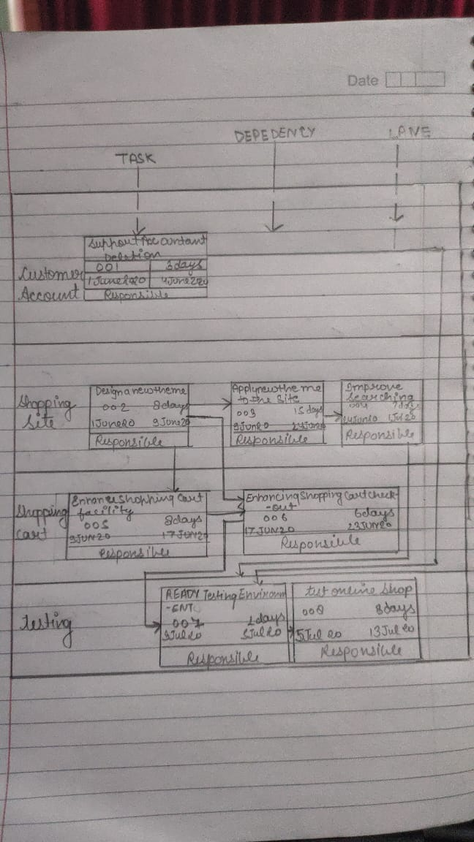

MOB- MOD E-SHOPPING DIAGRAM

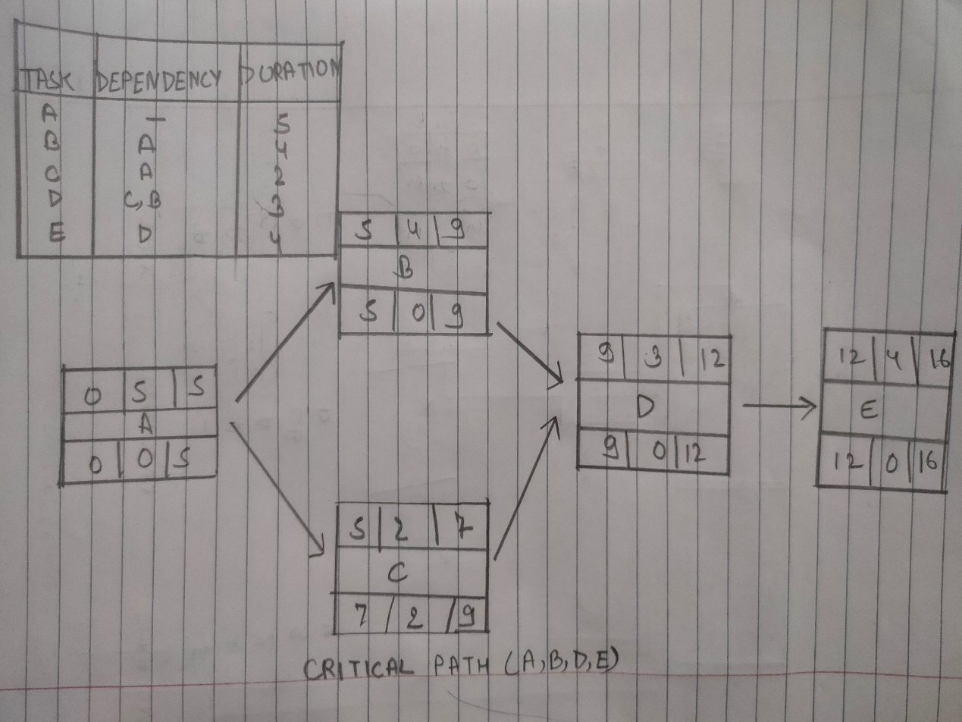

COMPLETE DURATION PROCESS

Algorithm

Step1: Initialization username and password.

Step 2: Check the username and password. If invalid username and password then go to step 1 otherwise go to step 3

Step 3: Check inter operator in admin or user. If admin go to step 4 otherwise go to step 8

Step 4: If create a new user go to step 5 otherwise go to step 6

Step 5: Fill up the information in registration form and create a username and password and fill up the other information of this new user go to step 9

Step 6: Written detail of following in the user table Username ,password, first name ,last name gender, state ,zip code, contact number, email id and IS admin

Step 7: If request issue then update user IS admin not information and entry in the user table go to step 9

Step 8: Go to step 6

Step 9: End

# State Chart Diagram

A state diagram is a type of diagram used in computer science and related fields to describe the behavior of systems. State diagrams require that the system described is composed of a finite number of states; sometimes, this is indeed the case, while at other times this is a reasonable abstraction.

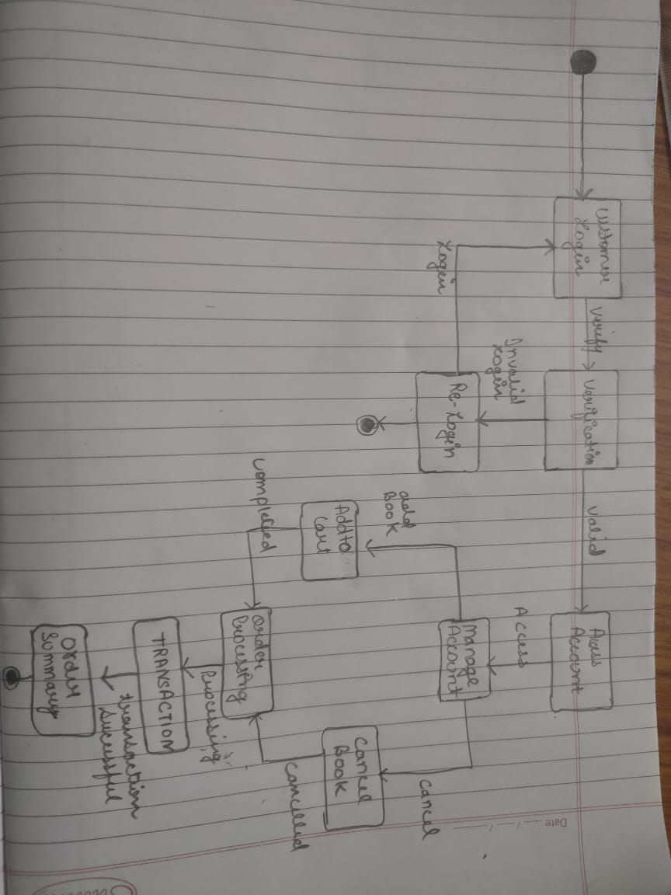

# Sequence Diagram

In **software engineering**, a system **sequence diagram** (SSD) is a **sequence diagram** that shows, for a particular scenario of a use case, the events that external actors generate, their order, and possible inter-system events.

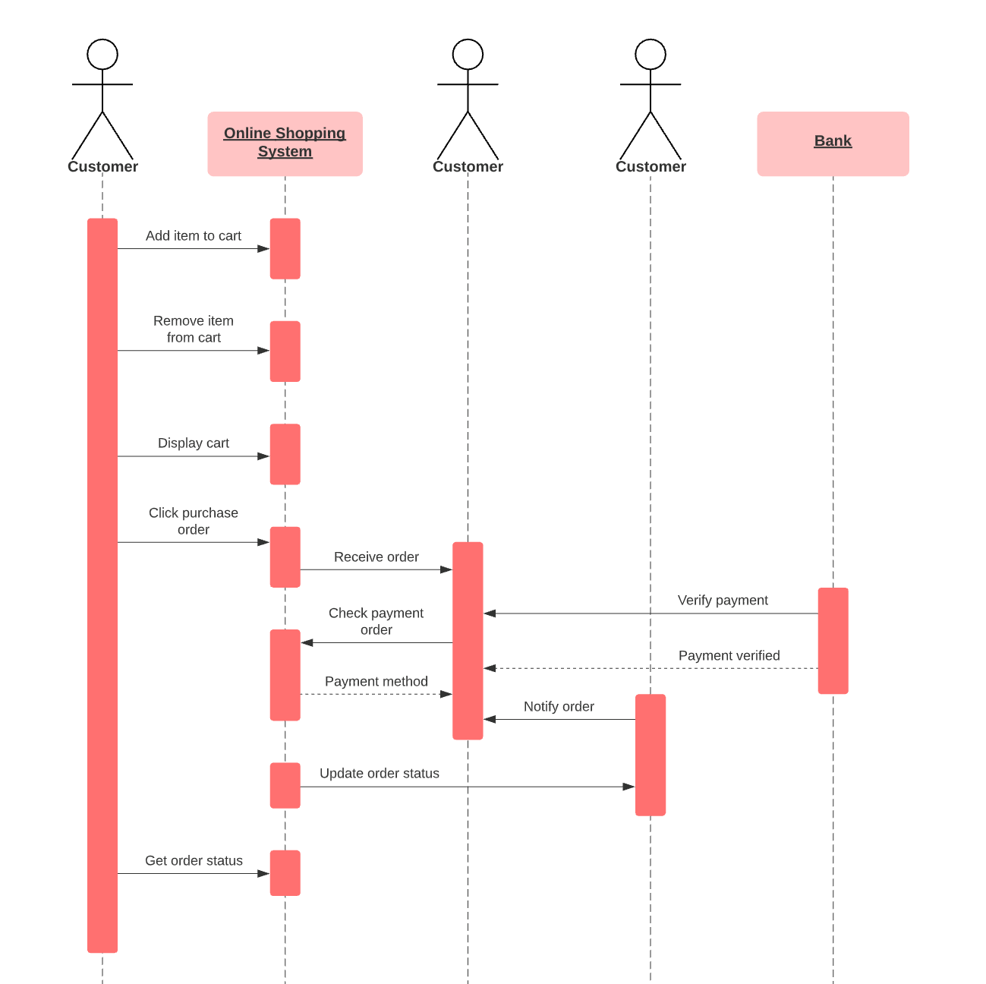

# Abstract Views

MOB-MOD is an initiative to provide a customized and personalized smartphones to the customers.Coustomers can add all the nessecary parts according to thier need and desire in our development environment.The user needs to pay only for their utility parts and for needless features which may cost them high price unnecessarily.

The steps to use our services are:-

First login or signup incase you are new customer to our website.

After you are successfully logged in you either directly go into our customization zone where you can add customize you own smartphone or you can browse for any specific parts which is new into the market.

After you enter into our cutomization zone you can refer to our list of mandatory parts which is nessecary to have inorder to make a complete samrtphone.Here itself you add any latest technology in your smartphone according to your needs.

After you complete customizing your smartphone you can either place it into your cart or order directly.

You have to make a successfull payment inorder to recieve the product.

After we confirm your payment you will recieve you order and delivery summary.

We also provide a relaxation of two days after the final order is confirmed inorder to make any further changes.

# Class Diagram

In **software engineering**, a **class diagram** in the Unified Modeling Language (UML) is a type of static structure **diagram** that describes the structure of a system by showing the system's **classes**, their attributes, operations (or methods), and the relationships among objects.

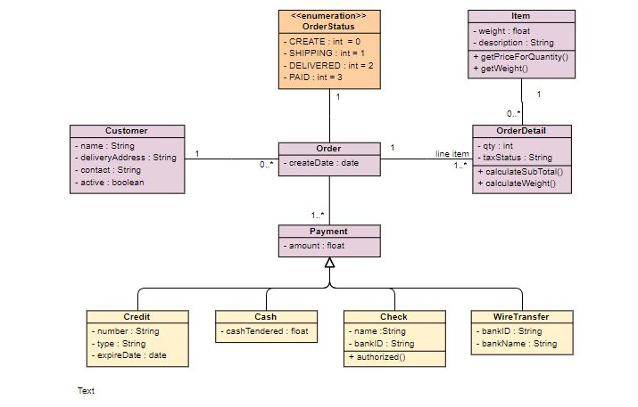

# Use of Agile Methodology in Project

The methodology upon which the project is to be carried on in any organization totally depends upon the nature of the project. For our project we undertook “Agile Methodology”

which best suits our needs and demands.

Agile Methodology – Agile methodology is a practice that promotes continuous iteration of development and testing throughout the software development lifecycle of the project. Both development and testing activities are concurrent unlike the Waterfall model .

The agile software development emphasizes on four core values.

⦁ Individual and team interactions over processes and tools

⦁ Working software over comprehensive documentation

⦁ Customer collaboration over contract negotiation

⦁ Responding to change over following a plan

There are various steps which makes agile a complete methodology. Those steps as incorporated in our project are discussed below in detail.

1} Requirement and Analysis: The process of agile methodology starts with a detailed planning and discussion about the project. The project manager along with the project owner discuses the functionalities and features about the project. The project manager notes down all the features as demanded by the owner. The owner on the other hand holds the responsibility to acknowledge the manager completely about the project.

Our project manager made sure to question the user until the user was satisfied about our final plan. The final plan was then converted to the company project with the agreement of the user. We made sure that the website holds the efficient search algorithm, payment technique,and an efficient auto-suggestion according to the user.

2} Design: This step involves the initial architectural designing of the project. The final plan is set into smaller tasks. Each task is distributed among the project team according their respective areas of expertise. This is the stage where the team has to decide features which has to come under primary and secondary list. The team should the best interface which is easy to understand and does does not involves any unnecessary complex programs. The interface of the application of the program should be fast while loading and portable on sizes of the screens.

Our project is built in such a way that the user does not have to have a very speed internet. The API’s used are very fast in loading and easy to understand. The consumers do their payment very securely.

3} Development: This step involves the real coding and development of the application. The developer team is approached in order to assign them tasks. In this step the developer team and business end should be in continuous touch of each other. The developer must continuously present their progress to the users in order to take any preferable review for further changes.

The developer must first build the beta version of the application to upload it on any platform. The consumers can use that website and suggest any missing features which can improve the appearance and working of the application.

4}Quality Assurance: This step approves the Quality of the application build by the developer team. The Quality Assurer must know in advance the failures of the features in order to prevent it in advance from failing. The user should have no issue in near future after the release. The team should bring upon any changes which are not certified by the quality team.

5}Deployment: Agile deployment may be seen as simply another testing step since multiple development deployment are performed between production deployments. QA "users" are deeply involved in improving the system by providing frequent feedback. These are not system or organization-wide deployments. The code is deployed to a QA or testing environment that is accessible to specific users and as close as possible to a real-world environment. That way, users can continuously test the software and send it back for improvement. In some cases, patches may actually be added in the production environment. Or, the product may be sent back for more iterations in development. And, sometimes, pilot or beta deployment to a limited number of end users in the final environment may also be done for even greater insight into real-world usage.

6}Release to the market: The last and the final step is release into the market. The complete tested application is released into in many releases. Each release contains some additional features as compared to its previous release. The features are added according to the past experience and failures.

Our developer team would always strive for the betterment of the user. The team will always be ready for making any additional features in the future releases of the application. If the user wants an improved graphics, payment system or a self customization zone within the application. If the user wants they can design their own back covers for their smartphones in our future releases.

LINK FOR GITHUB-<https://github.com/Arnav152/Brood/upload/master>